

EXCEL ESTIMATE
&
INVOICE PROGRAM
MANUAL

Revision
September 8, 2026

Table of Contents
1. Introduction 5
2. Basic Excel Program Layout 6
Excel Sheets Standard Start Layout 6
Start Sheet 8
Dashboard Form 9
3. Project Information for Estimates 11
4. Pay Items 12
Pay Items Version Prior to April 1, 2025 12
Pay Items Version 2.0 after April 1, 2025 14
5. Engineer’s Estimate 15
6. Form 900 16
7. Form 902 16
8. Assembly Green Project Covers 16
9. OSARC Preliminary Estimate 16
10. Bid Tab 17
11. Base Fuel Adjustment 17
12. Update Database with Winning Unit Cost 17
13. Letting Results 17
14. Contractor’s Estimate 17
15. Export Pay Item Database to SQL 18
16. Create the Initial CAD-002 Template 18
17. CAD-002 Monthly Detail Invoice 18
CAD-002 Version before April 1, 2025 18
Invoice Sheet Overview and Layout 20
CAD-002 Version 2.0 after April 1, 2025 21
Base and Monthly Fuel Adjustment before April 1, 2025 22
Base and Monthly Fuel Adjustment Version 2.0 after April 1, 2025 24
CAD-002 Version 2.0 after April 1, 2025 25
18. Engineering Services Payment Invoice 27
Engineering Services Payment Invoice Version before April 1, 2025 27
Engineering Services Payment Invoice Version 2.0 after April 1, 2025 28
Asphalt Pay Item Fuel Adjustments 28
Chemically Treated Soil Pay Item Fuel Adjustments 28
Fuel Adjustment Codes 28
Create New Monthly CAD-002 Invoice 29
Update to the CAD-002 Template 29
19. CAD-001 Monthly Summary Invoice Template 29
20. Change Order 30
21. Mobilization Calculation Pay Item S-200-A 30
22. Maintenance of Traffic Calculation Pay Item S-618-A 31
23. Supplemental Agreements and Special Functions 31
Special Functions Version before April 1, 2025 31
Special Functions Version 2.0 after April 1, 2025 32
24. Fuel Adjustments 32
Fuel Adjustment Codes 32
Fuel Adjustment Calculations 32
Fuel Code E - Excavation & Embankment (Except Structure and Foundation) 33
Fuel Code GY - Granular Materials 33
Fuel Code GT - Stabilizer Aggregates or Coarse & Seal Aggregates 33
Fuel Code M - Subgrade & Base Mixing Items 33
Fuel Code B – Hot Mix Asphalt (HMA) 33
Fuel Code D – Asphalt Drainage Course 34
Fuel Code C – Portland Cement Concrete (NOTE: Not currently in the program) 34
Fuel Code S – Bridge Items, Structural Concrete, Pipe Culverts, (Including Foundation & Structural Excavation and all other Concrete related items) 34
Fuel Code A2 – Asphalt for Surface Treatment 34
Fuel Code A3 – Asphalt for Prime 35
Fuel Code A4 – Asphalt for Curing Seal 35
Fuel Code A5 – Asphalt for Bituminous Treated Roving 35
Fuel Code A6 – Asphalt for Asphalt Drainage Course 35
Special Pay Item Fuel Adjustments 35
Damages & Forfeitures 36
25. Advancements 36
26. Training Videos 38
27. Cost Savings Project Summary 40
Project Management System Replacement 40
Estimate Program Replacement 41
28. Process FlowChart 42
29. Training Class Course Outline 44

Introduction
This manual was developed to train users on the best methods to use the EXCEL ESTIMATE AND INVOICE PROGRAM. This manual is not intended to be an all-inclusive training guide because the flexibility and vast capabilities of Excel are outside the scope of this manual. This manual was created to help a new user get started. This program was created with a lot of flexibility to add content without restrictions. In addition, advanced Excel users may also be able to utilize or manipulate this program to expand its capabilities beyond the predetermined steps recommended by this training manual.
This manual will discuss the following and answer questions that many users might have:
- Where to download the most recent revision?
- How do I get started?
- Review of the sheets that are present in the blank Excel program
- Who do I contact for help?
- Potential errors users may encounter
- Basics of how the Excel program works
- Advanced Excel user options
This Excel program’s current limitations are as follows for versions prior to April 1, 2025. The Excel Program Version 2.0 has restrictions but is not limited to the below constraints.
- 24 maximum monthly CAD-001 and CAD-002 invoices
- 11 maximum separate change orders initiated. There is no limitation on how many pay items can be changed on a single change order.
- Participating and Non-Participating Items
- Pay item maximum of 225
- The following construction category types are available for user selection:
  - Roadway
  - Erosion Control
  - Bridge
  - Box Bridge
  - Eight (8) User Defined additional type categories
- CAD-001 and CAD-002 Monthly Invoices
  - Fuel adjustments are supported in the program. The program does not correctly calculate the fuel adjustments for pay items on a monthly invoice that were not performed within that month. The calculation is based on the base and current month values. A separate monthly specific invoice should be used relative to month in which the pay item work was performed.
  - Addition of new pay items through supplemental agreement available
  - Eight (8) User Defined special situations for pay reductions or supplemental agreement additions of new pay items or other special types can be added by the user. This is basically a catch all for odd situations.
  - Special Pay reductions are supported in the program. The program was created to be flexible and contact OSARC if you have any questions regarding unusual circumstances.

Basic Excel Program Layout
The OSARC Estimate / Invoice Program is a macro-enabled Excel workbook. The file must have macros enabled in order to function. Deleting or renaming sheets may cause problems.

Excel Sheets Standard Start Layout
The program contains the following sheets that should never be deleted. Some of the sheets are hidden from the user. Each sheet is briefly described below:
- The following sheets are hidden and the user is not intended to interact with these sheet directly. These sheets are modified only by OSARC employees.
Program Version prior to April 1, 2025 | Program 2.0 Version after April 1, 2025 | Description
Project_PayItem_Database | Database | NA
Data_Validation | DATA_VALIDATION | NA
DataProject | Project_Data | NA
PayItemList | PayItemList  PayItemList2024  PayItemListMDOT | Program 2.0 contains a more comprehensive pay item list for the user to search for pay items.
NA | PAYITEMTYPE | NA
NA | PAYITEMTYPE_SUPPLEMENTAL | NA
Not hidden on this version | AvgUnitCost | File containing the data downloaded to produce average unit cost data reports.
Not applicable | Image | NA
Subtotal_Calculator | NA | NA
Subtotal_Calculator_Edit | NA | NA
Not hidden on this version | CAD_Template | The CAD-002 contains the detailed pay item and fuel adjustment data submitted for payment.
Not hidden on this version | EngPayInv | This sheet is used to process the County Engineer’s payment for administration of the project. This sheet is used for “STATE FUNDED” projects only and prints as “Portrait” style. This sheet extracts data the most recent data from the CAD-001 sheet and calculates the Engineering services payments at the specified intervals for preliminary, 25%, 50%, 75% and 100%. These intervals are interchangeable and can be used in various sequences. However, a maximum of 5 invoices is currently the maximum.
Not hidden on this version | EngPayInvFedFund | This sheet is used to process the County Engineer’s payment for administration of the project. This sheet is for “FEDERAL FUNDED” projects only and prints as “Landscape” style. This sheet functions identically to the EngPayInv sheet otherwise.

The following sheets are visible to the user and most of the document is locked to prevent unintended errors. Contact OSARC employees before unprotecting a sheet. Some of these sheets are hidden before the file is returned for the construction phase of the project.
Program Version prior to April 1, 2025 | Program 2.0 Version after April 1, 2025 | Description
START | START | This sheet contains instructions and a general workflow to help a user navigate the program process from the creation of the Engineer’s Estimate until the Final Invoice submitted for the project. The buttons on this sheet navigate to user forms.
ENG_Estimate | ENGINEER | This sheet is the Engineer’s Estimate.
900 | 900 | This sheet is the notice to contractor’s and published as the local advertisement. In this sheet, the participating and non-participating items are combined together. In all other areas of the program, these items types are identified separately.
902 | 902 | The sheet is a line item list of pay items used for bidders to enter their quantities.
GreenCover | GreenCover | This sheet is used to create the green cover sheet used in the final assembly process.
SA_Estimate | OSARC | This sheet is the OSARC Preliminary Estimate.
BIDTAB | BIDTAB | This sheet is used to collect data during the bid letting process. The sheet calculates values in order to determine accuracy and worthiness of the bids submitted.
WebBidList | WEBBIDLIST | This sheet is used with the BIDTAB sheet in order to create the pay items list that is posted on www.osarc.ms.gov for the upcoming bid lettings.
Contractor_Est | CONTRACTOR | This sheet is the Contractor’s Estimate.
LettingResults | LettingResults | This sheet extracts data from the BIDTAB sheet and creates the results of the bid letting which is posted on the OSARC website.
CAD-001 | Hidden and combined with the CAD-002 on this version | This sheet is the monthly summary invoice that corresponds to the CAD-002. The CAD-002 acts as a template for all subsequent invoices. This form is also known as the monthly recap estimate. The sheet name is automatically generated as CAD-001_No_1 and so on. The associated CAD-002_No_1 must be created before generating the CAD-001.
CAD-002 | Hidden and combined with the CAD-001 on this version | This sheet is the monthly detailed invoice. This form is also known as the monthly estimate. The CAD-001 acts as a template for all subsequent invoice summaries.
AvgUnitCost | Hidden on this version | This sheet is not present in the initial file. This sheet is created when the Contractor’s Estimate is created in order to export each project’s awarded unit cost to an SQL database.

Start Sheet
The “Start” sheet is the typical start location for a user to begin using this program. The version of Excel Program is annotated here and in the header of the CAD-001 and CAD-002.
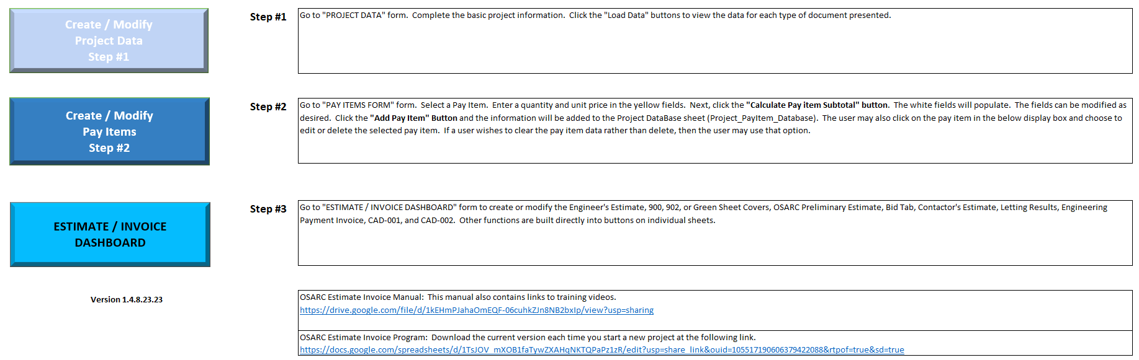
The “START” sheet for Version 2.0 presented below.
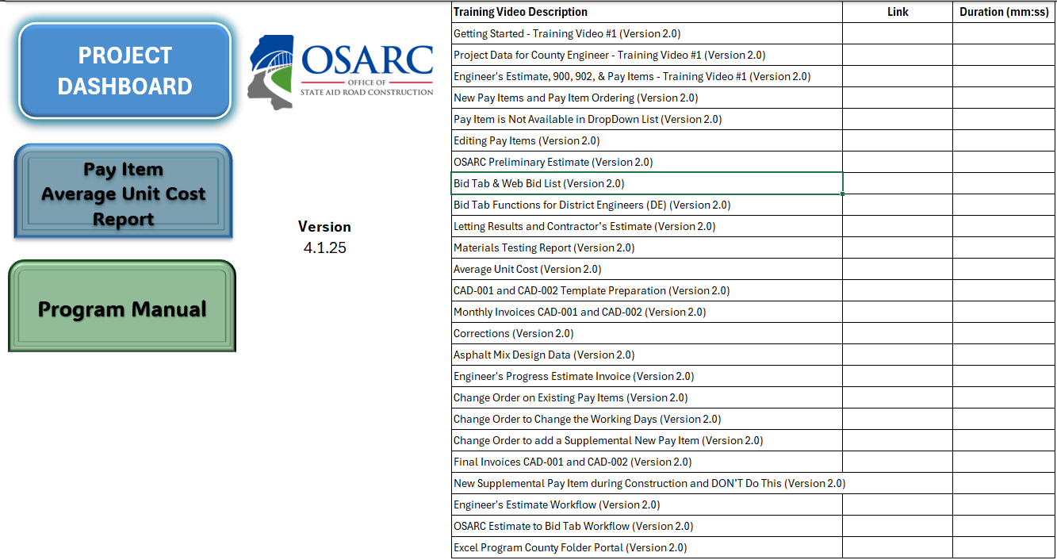

Dashboard Form
This “Dashboard” form can be accessed from the “START” sheet. This form is basically a dashboard for users to complete various task. This dashboard form gives the user a guide to this entire process. Navigate on the different tabs to view the various functions within the program. The tabs separate distinct functions within the program.
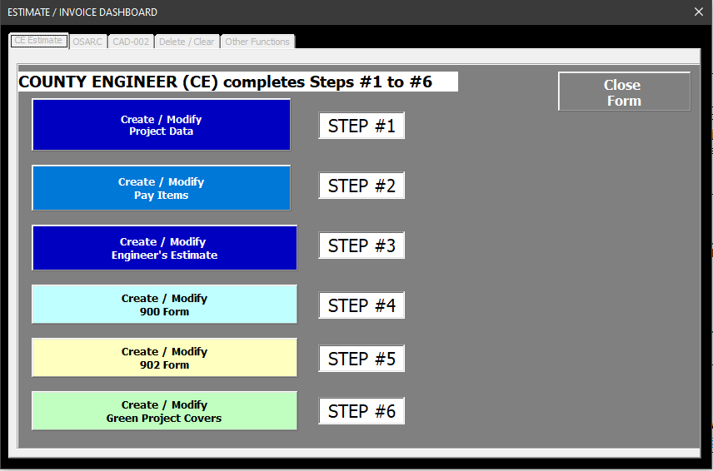
The “Dashboard” form for Version 2.0 presented below. The dashboard has been streamlined for the user to efficiently navigate one (1) single form without moving from different screen form to another. The workflow is essentially the same as the previous version. The major difference is how the “Base Fuel Data” and “Monthly Fuel Data” are entered, and how the user creates the next monthly progress payment (CAD-001 and CAD-002). Also some of the data entry has been moved to forms instead of direct entry onto the Excel spreadsheets and new fields have been added to gather more data.
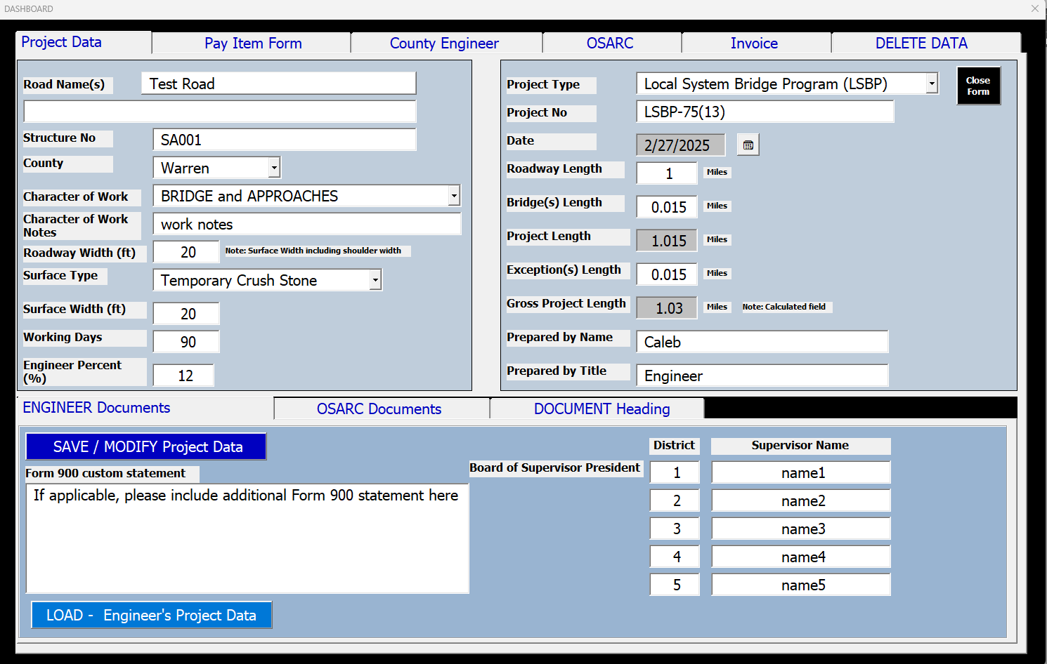

Project Information for Estimates
The County Engineer (CE) creates the “Engineer’s Estimate” by completing Steps #1 to #3. The project information is entered in the ‘PROJECT DATA” form for Step #1. Here is a list of this forms functionality:
- Any text can be added to this form. The drop down menus can have alternate data entered by the user but the these drop down selections are recommended.
- The “County” and “Project No.” fields are required.
- “Load” data will show the populated information on the selected sheet. The form is blank when it opens. The user must click load to view the data available in a respective sheet.
- “Save / Modify” will save or overwrite the data on the respective estimate sheet and the DataProject sheet.
- “Delete” data will delete the populated information on the selected sheet and the DataProject sheet.
- The “Form 900 Electronic Bidding Statement” and “Board of Supervisor President” fields are added so the user can retain additional information on the Form 900 without it being deleted every time the form is updated because of pay item changes.
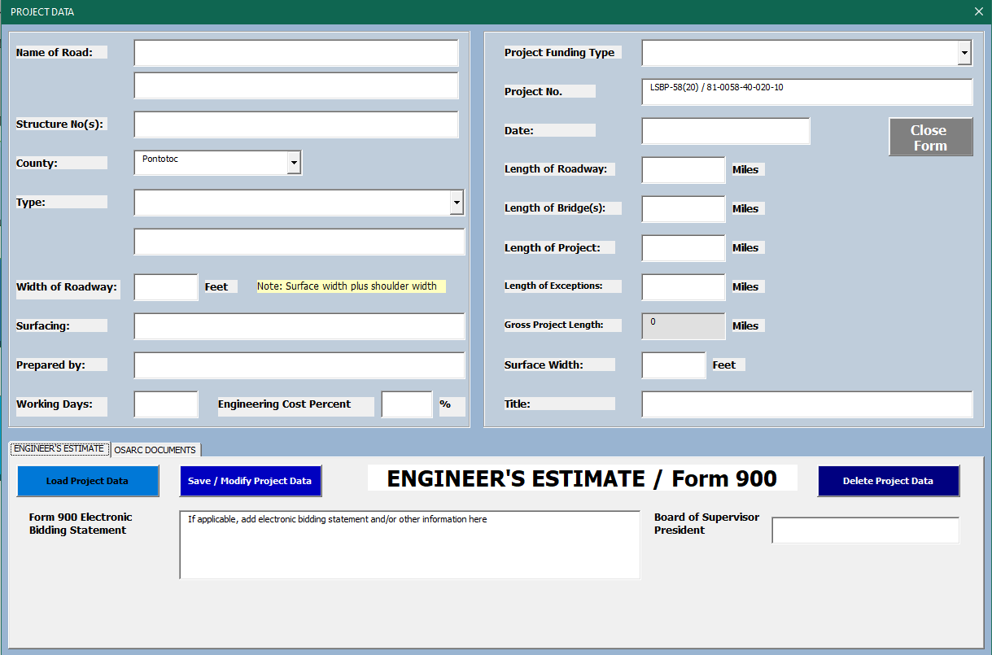
The “Project Data” form for Version 2.0 is presented in Section 2 of this document. No major changes except the addition of the Board of Supervisors name and associated district.

Pay Items

Pay Items Version Prior to April 1, 2025
The CE creates pay items used for the project. The pay item information is entered in the ‘PAY ITEMS” form for Step #2. See the below example of a typical project.
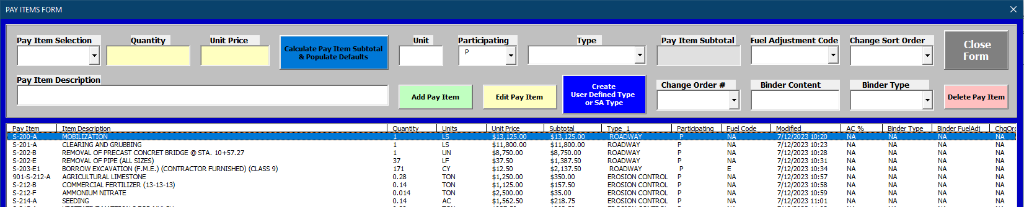
Here is a list of this forms functionality:
- The “Pay Item Selection” field is retrieving pay item information from the sheet “PayItemList”. The information is not retrieved until the “Calculate Pay Item Subtotal & Populate Defaults for White Fields” button is clicked.
- The “Quantity” and “Unit Price” fields must be populated to calculate the subtotal.
- All fields require a data entry.
- Data is temporarily sent to the “Subtotal_Calculator” sheet to calculate and retrieve data.
- If a pay item does not exist, it can be created by completing all the fields. However, this will not add the new pay item to the “PayItemList” sheet permanently. New pay items can be added permanently and this process will be described later. CRITICAL NOTE: If the user adds a new pay item, please ensure that the program sorted the pay item alphanumerically. If not, then contact OSARC to update the sorting.
- If the quantity and unit price change, the user must calculate again by clicking the button.
- Adding pay items copies the data to the “Project_PayItem_Database” sheet and also the data in this sheet will display in the list box as the user is creating the pay items for the project.
- Click the “Create User Defined Type or SA Type” button 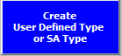to create a custom “Type” field other than Roadway, Erosion Control, Bridge, or Box Bridge. This opens a new form and allows the user to improve the separation of pay items if desired. A maximum of 8 new types can be created. After saving the data, it is recommended to select newly added type from the “Type” drop down selection menu rather than typing directly. This button is also used to create types of supplemental agreement pay items used in the CAD-002 and is considered a ”catch all” for many scenarios.
- The “Add Pay Item” button does not calculate automatically when the button is clicked. Hence, if a value is changed after clicking the blue calculate button, a user must click the button again prior to adding the pay item.
- The “Edit Pay Item” button is used to edit pay items “Quantity” and/or “Unit Price” typically but can be used to edit the participating status and fuel code. During the construction phase of the project, the asphalt mix design data is updated her for the binder content and binder type as well as identifying change orders for pay items. The “Pay Item Selection” is grayed out and not editable.
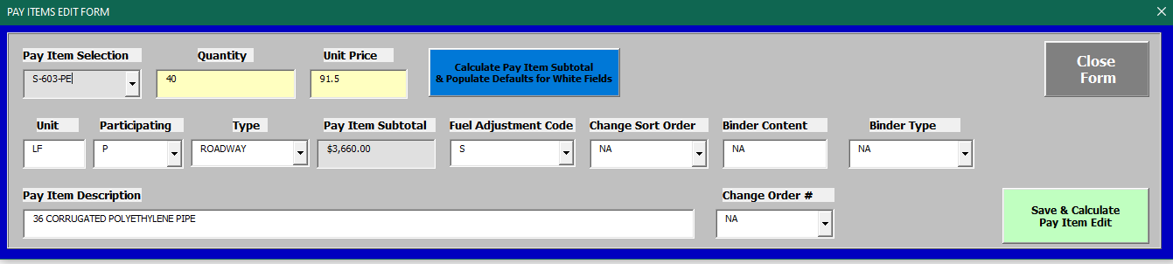
- CRITICAL NOTE: DO NOT TYPE data directly into fields with “drop down” control selections. This can and probably will cause a program error.

Pay Items Version 2.0 after April 1, 2025
There are some significant changes to the below pay item data entry form. The following is a list of the important changes.
- The “Search” field is used to find the pay item and displays the entire description prior to adding the pay item.
- The user can toggle back and forth between OSARC 2004, OSARC 2024, and MDOT 2017 specifications in the “Search” field.
- The specification year of the pay item is shown.
- User Defined Types tab is the same as before but a separate form.
- Supplemental Pay Items / Corrections are only used during the construction phase for monthly progress estimates which is similar to the older version of the program. However, this function greatly increases the ability of the program in new ways.
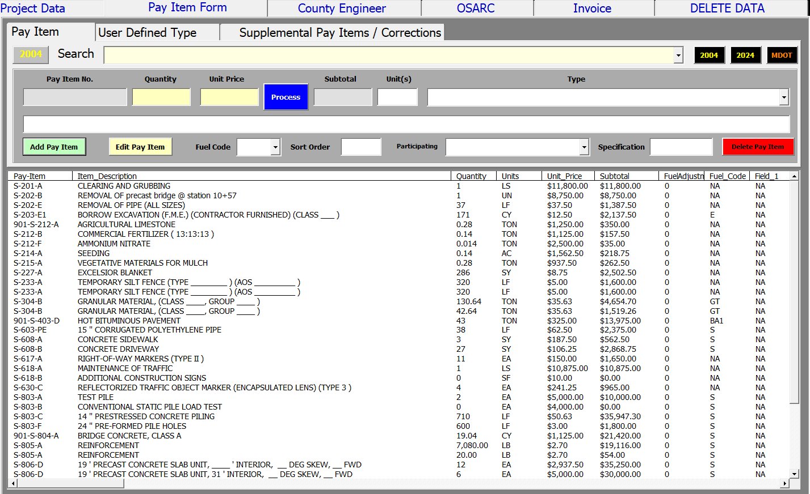
The Pay Item Edit Form has several new features. The primary new feature is the user’s ability to edit an individual pay item’s monthly fuel data. In turn, this will allow different fuel months on a single monthly progress payment.
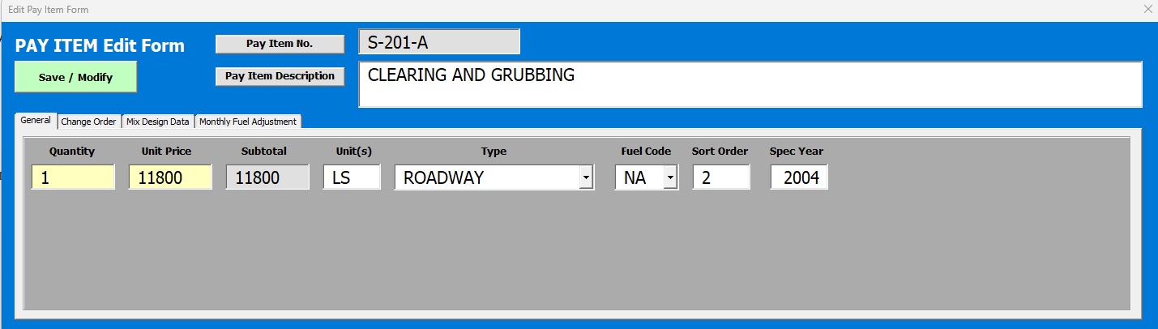

Engineer’s Estimate
The CE creates “Engineer’s Estimate” by clicking the “Create / Modify Engineer’s Estimate” button. This document is created in Step #3. This button is found on the “DASHBOARD” form.
Here is a list of the functionality:
- The pay items list created and saved to the “Project_PayItem_Database” sheet is used to create the Engineer’s Estimate. Hence, if the user modifies the pay items, the user then needs to click this button again to modify the estimate.
- The information is overwritten and does not create different versions or different copies.
Version 2.0 functions essentially the same way but is Step #1 and data is retrieved from the “Database” Sheet.

Form 900
The “900” sheet is created from the “Project_PayItem_Database” sheet by completing Steps #4. The 900 form groups together participating and non-participating items instead of separating the items which occurs on all other documents produced. Some data fields are automatically imported from the Project Data form. If the County population is below 20,000, then an additional editable field will appear on the 900 sheet.
Version 2.0 functions essentially the same way but is Step #2 and data is retrieved from the “Database” Sheet.
The “alternate” 900 sheet separates the participating and non-participating items on the sheet. Typically, the 900 combines participating and non-participating items together.

Form 902
The “902” sheet is created from the “Project_PayItem_Database” sheet by completing Steps #5.
Version 2.0 functions essentially the same way but is Step #3 and data is retrieved from the “Database” Sheet. The “902” sheet and the “Bidtab” line item numbers should correspond to each other.

Assembly Green Project Covers
The “Assembly Green Project Covers” sheet is created from the “Project_PayItem_Database” sheet by completing Steps #6.
Version 2.0 functions essentially the same way but is Step #4 and data is retrieved from the “Database” Sheet.

OSARC Preliminary Estimate
OSARC staff creates the “OSARC Preliminary Estimate” by completing Steps #7. Here is a list of the functionality:
- The OSARC Preliminary Estimate also uses the “Project_PayItem_Database” sheet to generate the data.
- Anytime the button is click, the sheet is cleared and data generated again.
- The “Funds” transferred to the project engineering payments fund is 12% of the subtotal items. However, the program does allow changing the default of 12% to other values for calculation.
- The “Contingencies” is 5% of the subtotal items.
Version 2.0 functions essentially the same way but is Step #5 and data is retrieved from the “Database” Sheet.

Bid Tab
OSARC staff creates the “BIDTAB” by completing Step #8, which contains multiple functions. Unlike the previous sets, the BIDTAB does not use a form.
Here is a list of the functionality:
- The data entered in the table “Bid Letting Results” will automatically sort the bidders into the below columns for data entry. The “Low Bid” will appear in Column AC to AD and the low bidder unit prices must be entered here, because the low bidder data is copied to the contractor’s estimate.
- The “STATUS of AWARD” and “Date Awarded on” must be populated if the user wants this information imported to the “LettingResults” sheet.
Version 2.0 functions essentially the same way but is Step #6 and data is retrieved from the “Database” Sheet. The OSARC District Engineer (DE) functions are essentially the same but method has changed for the entry of the bidders information.

Base Fuel Adjustment
Version 2.0 functions base fuel data is entered by OSARC employees at Step #7. This is a workflow change from the previous version.

Update Database with Winning Unit Cost
Version 2.0 functions is a new function. This will take winning bidder #1 unit cost and input the data directly into the Database sheet, hence eliminating manual data entry.

Letting Results
The “LettingResults” sheet is created from the Bid tab data from the BIDTAB sheet in Step #9.
Version 2.0 functions essentially the same way but is Step #8 and data is retrieved from the “Database” Sheet.

Contractor’s Estimate
OSARC staff creates the “Contractor’s Estimate” by completing Step #10. The “ContractorEst” sheet is created from the “Project_PayItem_Database” sheet in Step #10. Also, the “Low Bidder” information is copied automatically onto the Contractor’s Estimate. However, the unit prices must be manually updated to match the low bidder’s unit price. Each pay item must be updated using the Create/Modify Pay Item form.
Version 2.0 functions essentially the same way but is Step #10 and data is retrieved from the “Database” Sheet.

Export Pay Item Database to SQL
OSARC staff exports the project pay item data by completing Step #11. The average unit cost of pay items for all projects is determined based on the data exported from each project.
Version 2.0 functions essentially the same way but is Step #13 and data is retrieved from the “Database” Sheet.

Create the Initial CAD-002 Template
After completing Steps #1 to #11 this Excel file is ready to create the CAD-002 template. The user must perform the following steps to get started correctly:
- When clicking the “Create / Modify CAD-002 Template” button, the user is populating data from the “Project_PayItem_Database” sheet. Each time this button is clicked, the user replaces the CAD-002 data with any changes made to the pay items. For example, a change order can change pay items quantities and then the CAD-002 template needs to be updated in order to invoice accurately.
- After the initial CAD-002 is created, the user must enter the base fuel adjustment data based on the contract by entering the data on the “FUEL ADJUSTMENT DATA FORM”. The data is saved to the CAD-002 template sheet. Even if the CAD-002 template is updated, the base fuel adjustments are not changed during that update.
- If asphalt pay items are on the current project, the user must have add a binder content and binder type to the pay item. Each pay items associated with asphalt will need to be edited to add the binder type and content from the mix design. The binder type is case sensitive and a user must use the selection from the drop down menu.
Version 2.0 functions essentially the same way but is Step #11 and data is retrieved from the “Database” Sheet. The CAD-001 and CAD-002 templates are combined into 1 sheet in this version. Also these template sheets and other templates are hidden from the user in many case.

CAD-002 Monthly Detail Invoice

CAD-002 Version before April 1, 2025
The CAD-002 invoice acts as a template and this template can and most likely will change thoroughly the life of the project. The CAD-002 invoices have buttons on each sheet which are used by the user to perform actions necessary to producing the month’s invoice. Each invoice is essentially a separate independent sheet where all the calculations are performed once it is created.
Here is a list of the functionality:
Each CAD-002 monthly invoice is automatically named, and the newest invoice is automatically placed after the CAD-002 template sheet. For example, the first invoice is named “CAD-002_No_1”. The maximum number of invoices is currently 24.
The green button  creates each subsequent invoice.
The user should enter current period quantities into the highlighted yellow fields for each pay item prior to performing Step #2. Quantities for pay item S-200-A Mobilization and S-618-A Maintenance of Traffic do not need quantities entered. These amounts are automatically calculated by the program in Step #3 below.
The gray button 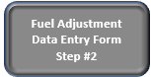opens a form so the user can enter the base and monthly fuel adjustment data. The data is saved to the current sheet the user is working on.
The blue button 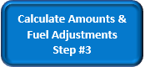 calculates the amounts and totals for this months CAD-002 invoice. Each time the button is pressed, the form recalculates. So if the user edits the quantities, the user needs to click the calculate button again to update.
The orange button 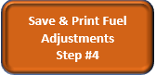 adds the base and monthly fuel adjustment data to the “DataFuelAdj” sheet and Prints the current invoices fuel adjustment summary. Clicking this button will find all available CAD-002 invoices and then populate the by overwriting the existing data on DataFuelAdj.
The red button 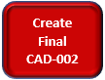 simply updates the form to say “Final” for the last invoice and automatically makes the S-618-A Maintenance of Traffic pay item equal to 1. CRITICAL NOTE: DO NOT click this button until the last invoice because it can cause a serious program error. Never hit this button on the CAD-002 template sheet.

Invoice Sheet Overview and Layout
The below image is a screen shot of a typical project. The information in the columns and functionality of the columns are explained as follows:
- Column A
  - Fuel adjustment for that specific pay item for this specific invoice current period
- Column B
  - Pay Item Number
- Column C
  - Fuel Adjustment Code if applicable
- Column E
  - Total quantity amount on the original contract unless a change order changes this amount. This column will change if a change order occurs and updates the contracted amount.
- Column F
  - The current period quantity used should be input by the user here. The yellow fill color indicates the user can edit this field.
- Column G
  - This column contains the accumulative quantity allowed to date.
- Column H
  - This column contains the unit of measure.
- Column I
  - This column contains the unit price of the pay item.
- Column J
  - This column contains the current accumulative cost for that specific pay. This column will highlight bright yellow and bold the text if the amount is $3000 greater than the contract estimate amount in Column K.
- Column K
  - This is the original contract estimated amount. This amount can change with the addition of a change order.
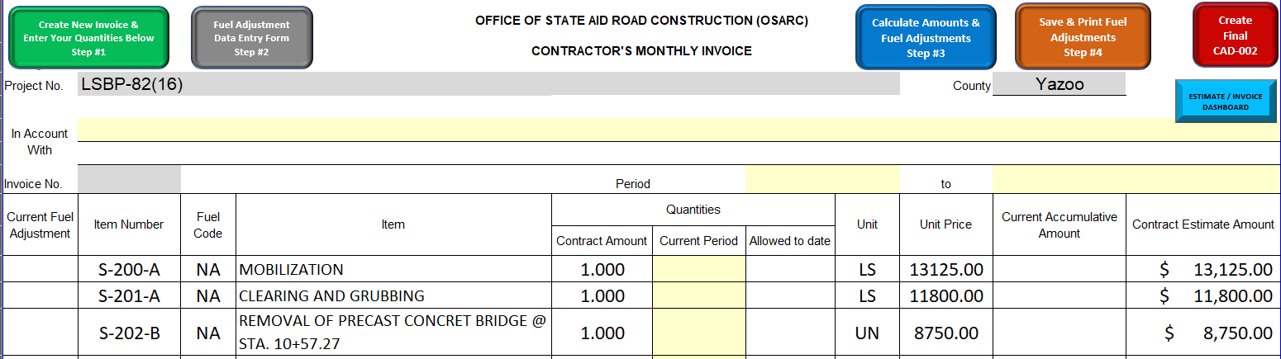

CAD-002 Version 2.0 after April 1, 2025
Version 2.0 performs the same functions as the previous version, but the workflow has changed. For example, the user would go to the Dashboard 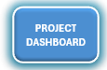to complete the monthly fuel adjustment and create the next CAD invoice.
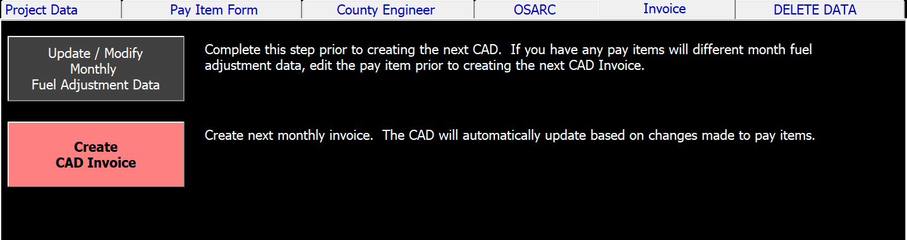
Essentially, the buttons on the top of the previous version have been moved. The Calculate 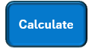 and Create Final CAD 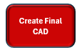buttons are the same function as before for users. See an example of the new CAD form below.

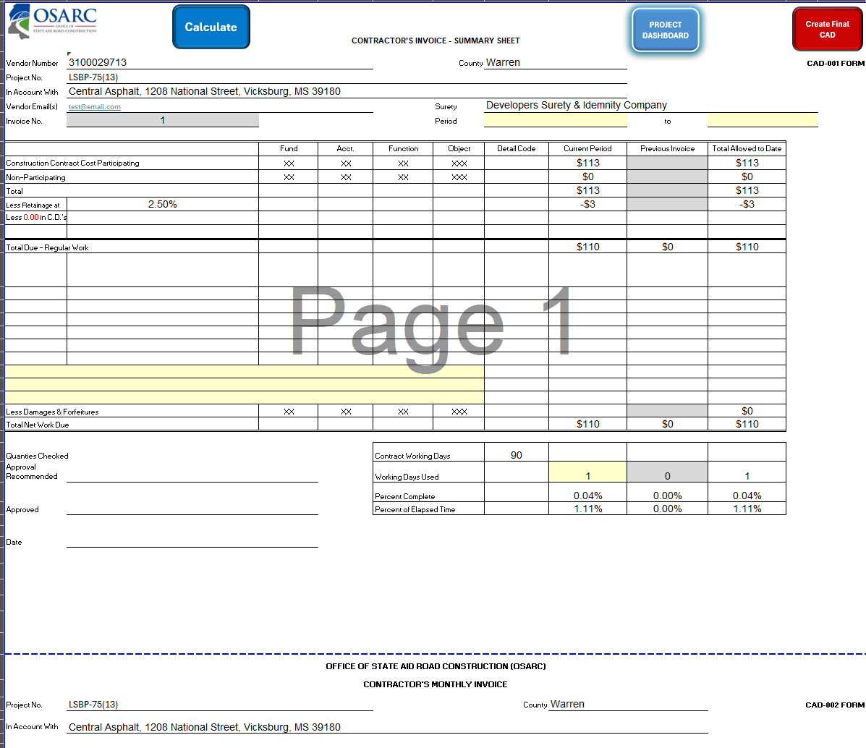

Base and Monthly Fuel Adjustment before April 1, 2025
The base fuel adjustment data is copied to the CAD-002 template from the Base Fuel Adjustment form. The monthly invoice CAD-002 copy data from CAD-002 and the base fuel adjustment data is on each CAD-002 invoice and also stored on the DataFuelAdj sheet. The user only needs to enter values for that affect pay items on the project. Hence, some fields can be skipped and remain a default “0”. Saving the form will overwrite the data each time.
The monthly fuel adjustments data is copied to the current sheet the user is actively using. The monthly fuel adjustment form works the same way as the base fuel adjustment form. A fuel adjustment is not calculated if the fuel adjustment differential is less than or equal to 5%. Data is entered on the following form which is accessible on the CAD-002.
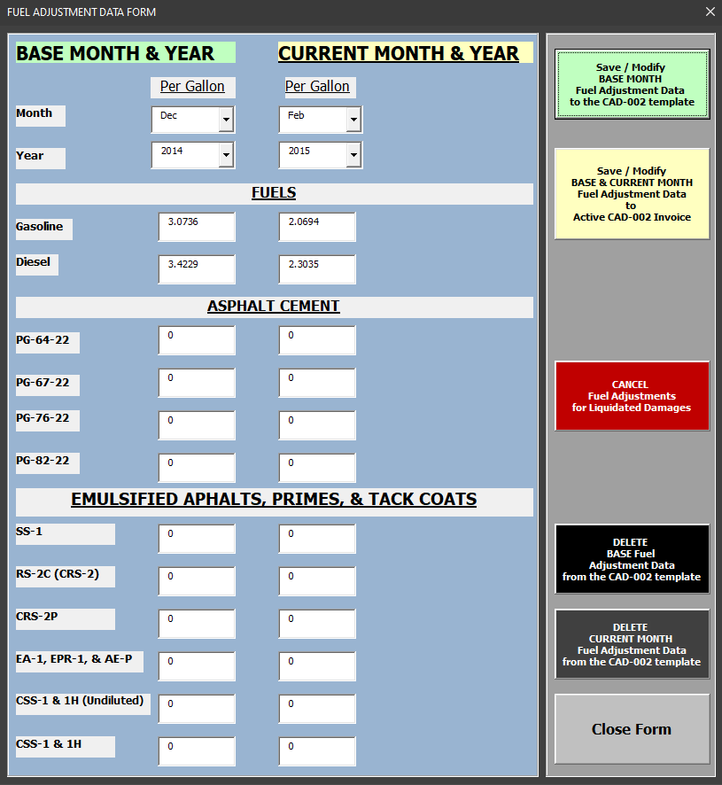
The light green button 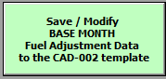 saves based values to ONLY the CAD-002 template.
The light yellow button 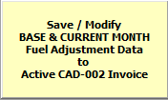 saves based values to the current CAD-002 invoice and saves the current values. This form shows the user what values are being used for current calculations on the active sheet.
The red button 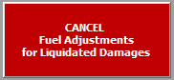 will zero all the values and show that the project is in liquidated damages and fuel adjustments are no longer applicable.

Base and Monthly Fuel Adjustment Version 2.0 after April 1, 2025
The base fuel adjustment data is entered by OSARC staff during the Roadway Final Assembly process. The user should not have to interact with this function.
However, the monthly fuel adjustments are entered here for all pay item. In addition, the user can modify specific pay items to have different monthly fuel adjustments. The user must complete this task prior to creating the CAD because the data must carry over to the monthly pay item data correctly.
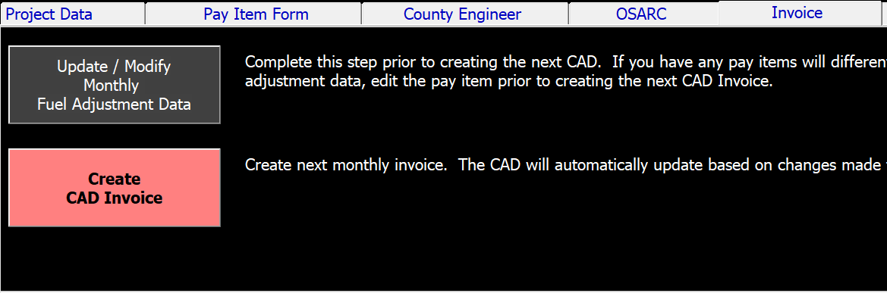
Below is an example of where an individual pay item fuel adjustment data can be altered.
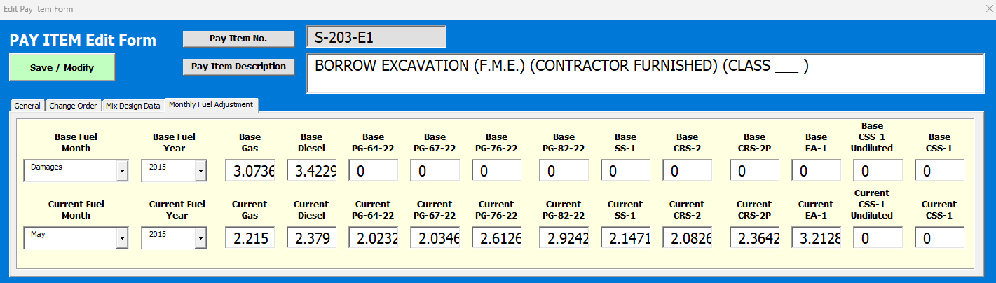

CAD-002 Version 2.0 after April 1, 2025
The CAD-001 and CAD-002 are now combined in the new version. The buttons and steps located on the top of the CAD-002 have been moved to the “Dashboard” form in order to improve the program’s abilities.
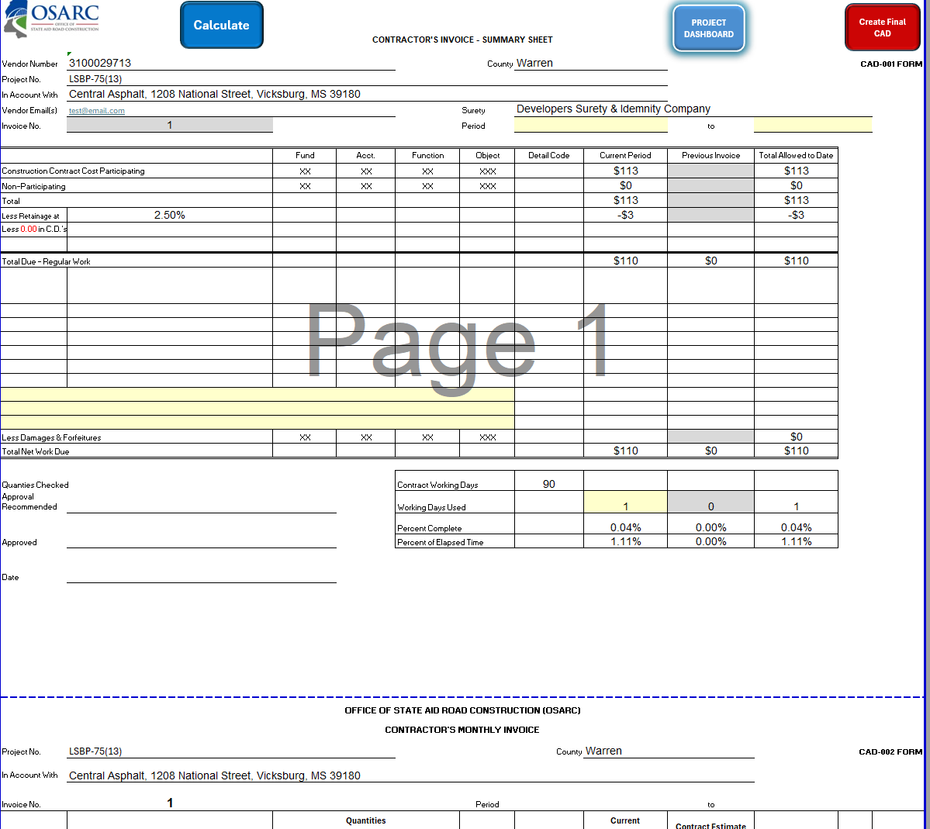
Under the “Invoice” tab, you can see the user must enter the Monthly Fuel Adjustment data prior to Creating the next CAD invoice. The “Engineer Services” invoice is also created from here as well. Most of the templated documents are now hidden from the user.
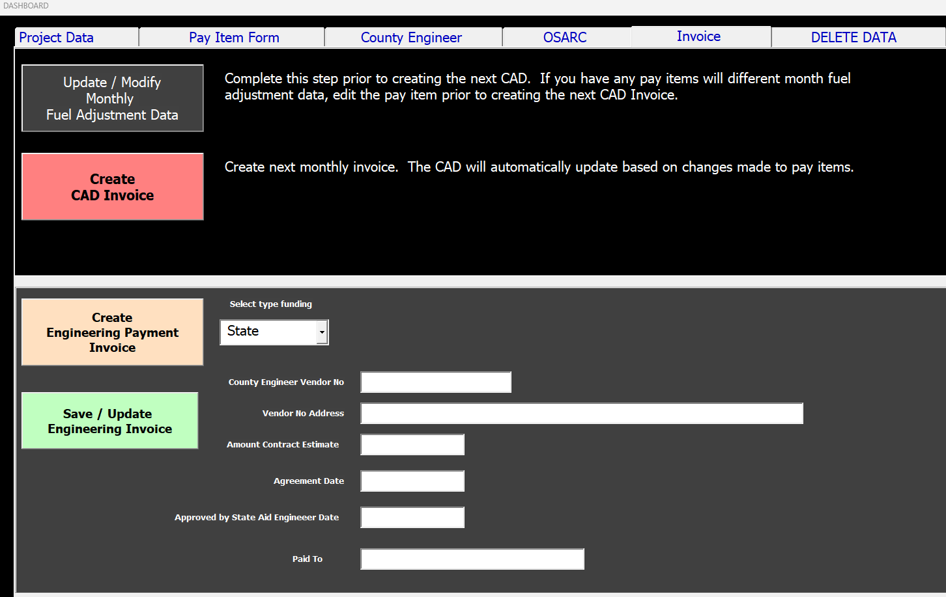

Engineering Services Payment Invoice

Engineering Services Payment Invoice Version before April 1, 2025
The Engineering Services Payment Invoice (EngPayInv) is used to calculate payments based on the predefine intervals of the Preliminary, 25%, 50%, 75%, and 100% project milestones. This sheet is only used for State funded projects and prints portrait style. The yellow fields are editable user input fields. The gray fields are imported data. The “EngPayInvFedFund” is only used for Federally funded projects and prints landscape style.
Here is a list of the functionality:
The user must prepare the EngPayInv template by entering the relevant data. The “Amount Contract Estimate” and “Engineering Fee %” must be entered. Upon selection of the “100%” final invoice payment, the user must enter the “Amount Final” in order for the calculation to work correctly.
The gray fields will collect information from the most recent EngPayInv and the most recent CAD-001 automatically after clicking the green button to generate the next invoice.
A user must select an option from Cell B7 for “Invoice of Payment for” to
The blue button 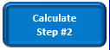 calculates the data after the user has prepared the form.

Engineering Services Payment Invoice Version 2.0 after April 1, 2025
The next engineering services invoice is produced directly from the “Invoice” tab located on the Dashboard form. Select the funding type and save the basic data to the template. This template is hidden from the user.
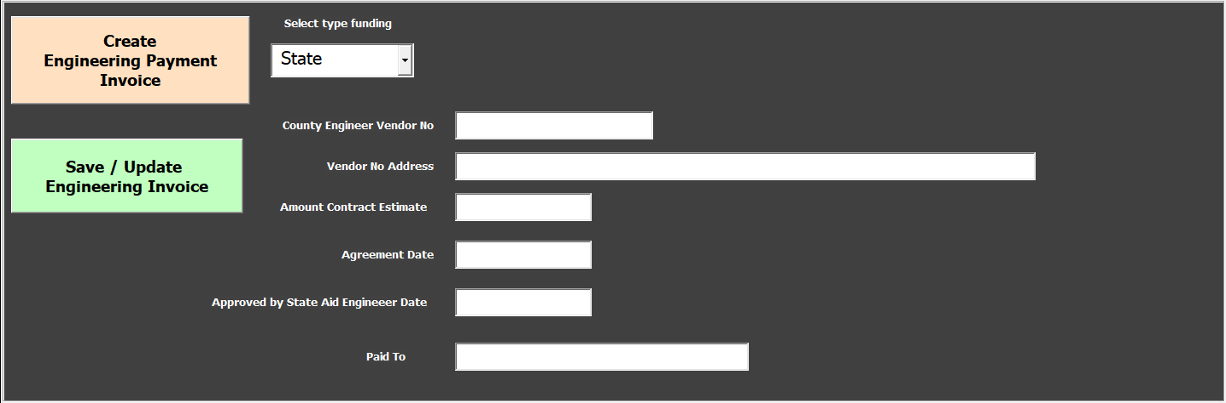

Asphalt Pay Item Fuel Adjustments
Each asphalt pay item has a fuel adjustment based on the asphalt content percent and binder type used for the asphalt mixture. The user has to edit the pay item to add this fuel adjustment or the fuel adjustment is not calculated.

Chemically Treated Soil Pay Item Fuel Adjustments
A fuel adjustment is possibly necessary based on the curing seal used. Contact the applicable OSARC District Engineer.

Fuel Adjustment Codes
Fuel adjustment codes are designated in Section S-109 on Page 1-86 and 1-87 of the 2004 Green Book. Code “B” is not used alone because “B A1” is used. However, this code has an additional special calculation. The calculations are presented in this manual. The following codes are case sensitive and must be entered correctly into the Excel Estimate / Invoice Program:
- E
- GY
- GT
- M
- B
- D
- C
- S
- B A1
- A2
- A3
- A4
- A5
- A6

Create New Monthly CAD-002 Invoice
Each new monthly invoice is created by clicking the green button on the top of the CAD-002 template or any of the existing invoices. Each invoice is subsequently named “CAD-002_No_1”, “CAD-002_No_2”, and so on. The sheets are placed automatically next to the CAD-002 in the order created newest to oldest.

Update to the CAD-002 Template
In order for the user to update the CAD-002, the following steps should be followed:
- Update the pay items by clicking on this  and using the pay items form.
- Next, the user must click on the  button to update the existing CAD-002 template if pay items are changed.
Version 2.0 functions essentially the same way. The CAD-001 and CAD-002 templates are combined into 1 sheet in this version.

CAD-001 Monthly Summary Invoice Template
The CAD-001 invoice acts as a template but unlike the CAD-002 monthly invoice, this sheet is not a complicated to modify because it simply copies information from existing CAD-002 monthly invoices and calculates amounts.
Here is a list of the functionality:
Each CAD-001 monthly invoice is automatically named, and the newest invoice is automatically placed after the CAD-001 template sheet. For example, the first invoice is named “CAD-001_No_1”. The maximum number of invoices is currently 24.
The green button  creates each subsequent invoice.
The yellow highlighted fields are user entered fields.
from the CAD-002 template when the CAD-001 initial template is generated. Otherwise, these fields can be edited by the user.
The blue button 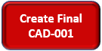 creates the final invoice. Unlike the CAD-002 which only edits text to create the final, the calculations are changing here because of the retainage.

Version 2.0 functions essentially the same way. The CAD-001 and CAD-002 templates are combined into 1 sheet in this version. Version 2.0 automatically updates the template before creating the next progress payment, so there is no need to complete Step #11 again.

Change Order
Changes orders modify the CAD-002 template by changing the original quantities. In order to capture these changes, the user must complete the following steps:
- Add or copy the pay item that needs a change order.
- Edit that added pay item and add the “Change Order” # and change the “Participating” field to “CCR”.
- Then, the user must edit the existing pay item and change it to the new quantity that is supposed to be allowed for the contract.
- Finally, the user must update the CAD-002 template.
Version 2.0 functions essentially the same way. The CAD-001 and CAD-002 templates are combined into 1 sheet in this version. Version 2.0 automatically updates the template before creating the next progress payment, so there is no need to complete Step #11 again.

Mobilization Calculation Pay Item S-200-A
This section presents the mobilization calculation. The program automatically calculates this number for the user. This calculation excludes the S-200-A and S-618-A total allowed to date.
$$If (\frac{Total Construction Current Participating and NonParticipating Item Cost }{Total Construction Current Participating and NonParticipating Item Cost}≥10 \% Then$$
$$S⎼200⎼A Mobilization Quanity=1$$
$$If (\frac{Total Construction Current Participating and NonParticipating Item Cost }{Total Construction Current Participating and NonParticipating Item Cost}(10-5 \% ) Then$$
$$S⎼200⎼A Mobilization Quanity=0.5$$

$$If (\frac{Total Construction Current Participating and NonParticipating Item Cost }{Total Construction Current Participating and NonParticipating Item Cost}(5-0 \% ) Then$$
$$S⎼200⎼A Mobilization Quanity=0.0$$

Maintenance of Traffic Calculation Pay Item S-618-A
This section presents the maintenance of traffic calculation. The program automatically calculates this number for the user. The previous program calculated the amount based on the “original” contract total construction item cost and did not include change order updates to the revised total construction item cost. This program calculates with the current amount of total contract amount which changes due to change orders.
$$S⎼618⎼A Maintenance of Traffic Quantity=$$
$$\frac{\begin{aligned}Total Construction Current Participating and NonParticipating Item Subtotal Cost+Total Current Fuel Adjustment Cost \\ - \left(S⎼200⎼A Moblization Cost\right)-(S⎼618⎼A Maintenance of Traffic)\end{aligned}}{Total "\text{Current" }Construction Participating and Non-Participating Item Contract Amount Total}$$
$$S⎼200⎼A Mobilization Quantity=0.0$$and $S⎼618⎼A Maintenance of Traffic Quantity=0.0$
IMPORTANT NOTE: The calculation may change if the “Allow to Date” quantity exceeds 1. Then, the program will automatically make the S-618-A quantity to equal 1 and subsequently revise the “Current Period” quantity to equal the previous invoice quantity for S-618-A to equal 1 minus the previous invoice quantity. The “Allowed to Date” value cannot exceed 1.000.
$$If (S⎼618⎼A Maintenance of Traffic Quantity>1 Then$$
$$S⎼618⎼A Maintenance of Traffic Quantity=[1- (S⎼618⎼A Maintenance of Traffic Quantity from previous invoice)]$$

Supplemental Agreements and Special Functions

Special Functions Version before April 1, 2025

Adding new pay items via supplement agreements and change orders can be accomplished using the “Create / Modify Pay Item Form”. The blue button is used as a catch all tracking method for the CAD-002 invoicing process. A maximum of 8 supplemental agreement types can be created. After saving the data, it is recommended to select newly added type from the “Type” drop down selection menu rather than typing directly.

Special Functions Version 2.0 after April 1, 2025
Under the “Pay Item Form” tab and the “Supplemental Pay Items / Corrections” tab, the user can add new items or make corrections.
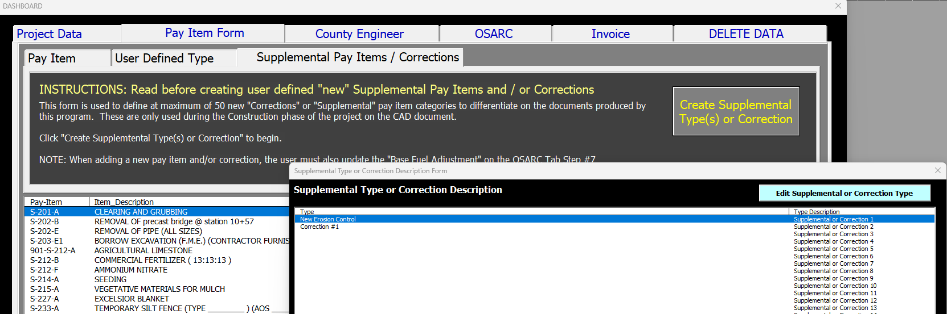

Fuel Adjustments

Fuel Adjustment Codes
Fuel adjustment codes are designated in Section S-109 on Page 1-86 and 1-87 of the 2004 Green Book. See the CAD-002 section for the actual codes needed for the program to work properly.

Fuel Adjustment Calculations
This section presents the formulas used for each fuel adjustment performed. For each pay item that requires a fuel adjustment, an adjustment is calculated for both gasoline and diesel fuel. Special pay items require and additional adjustment and the additional calculation is presented in that section.
For all pay items that require a fuel, the following formula applies to each fuel code. If the difference between the current month and base month fuel adjustment values are less than 5%, then there is no fuel adjustment.
$$If (Absolute Value\left[\frac{\left(Current Month-Base Month\right)}{Base Month}\right]>5\% Then=\$0.00 fuel adjustment$$

Fuel Code E - Excavation & Embankment (Except Structure and Foundation)
$$E= Excavation \& Embankment \left(Except Structure and Foundation\right)$$
$$E_{gasoline}= (Quantity this Period)× \frac{0.15 gal}{unit}×\left(Current Month-Base Month\right)$$
$$E_{diesel}= (Quantity this Period)× \frac{0.29 gal}{unit} ×\left(Current Month-Base Month\right)$$
$$E_{Total}= E_{gasoline}+ E_{diesel}$$

Fuel Code GY - Granular Materials
$$GY= Granular Materials$$
$${GY}_{gasoline}=(Quantity this Period)× \frac{0.57 gal}{unit} ×\left(Current Month-Base Month\right)$$
$${GY}_{diesel}= (Quantity this Period)× \frac{0.88 gal}{unit}×\left(Current Month-Base Month\right)$$
$${GY}_{Total}= {GY}_{gasoline}+ {GY}_{diesel}$$

Fuel Code GT - Stabilizer Aggregates or Coarse & Seal Aggregates
$$GT= Stabilizer Aggregates or Coarse \& Seal Aggregates$$
$${GT}_{gasoline}= (Quantity this Period)× \frac{0.40 gal}{unit}×\left(Current Month-Base Month\right)$$
$${GT}_{diesel}=(Quantity this Period)× \frac{0.62 gal}{unit}×\left(Current Month-Base Month\right)$$
$${GT}_{Total}= {GT}_{gasoline}+ {GT}_{diesel}$$

Fuel Code M - Subgrade & Base Mixing Items
$$M= Subgrade \& Base Mixing Items$$
$$M_{gasoline}=(Quantity this Period)× \frac{0.028 gal}{unit}×\left(Current Month-Base Month\right)$$
$$M_{diesel}= (Quantity this Period)× \frac{0.044 gal}{unit} ×\left(Current Month-Base Month\right)$$
$$M_{Total}= M_{gasoline}+ M_{diesel}$$

Fuel Code B – Hot Mix Asphalt (HMA)
$$B= Hot Mix Asphalt (HMA)$$
$$B_{gasoline}=(Quantity this Period)× \frac{0.78 gal}{unit} ×\left(Current Month-Base Month\right)$$
$$B_{diesel}= (Quantity this Period)× \frac{2.57 gal}{unit}×\left(Current Month-Base Month\right)$$
$$B_{Total}= B_{gasoline}+ B_{diesel}+{B A1}_{AC_{Content}\%}$$
See special fuel adjustment pay items for ${B A1}_{AC_{Content}\%}$ calculations.

Fuel Code D – Asphalt Drainage Course
$$D= Asphalt Drainage Course$$
$$D_{gasoline}= (Quantity this Period)× \frac{0.15 gal}{unit} ×\left(Current Month-Base Month\right)$$
$$D_{diesel}= (Quantity this Period)× \frac{0.49 gal}{unit} ×\left(Current Month-Base Month\right)$$
$$D_{Total}= D_{gasoline}+ D_{diesel}$$

Fuel Code C – Portland Cement Concrete (NOTE: Not currently in the program)
$$C= Portland Cement Concrete$$
$$C_{gasoline}=(Quantity this Period)× \frac{0.15 gal}{unit} ×\left(Current Month-Base Month\right)$$
$$C_{diesel}= (Quantity this Period)× \frac{0.11 gal}{unit} ×\left(Current Month-Base Month\right)$$
$$C_{Total}= C_{gasoline}+ C_{diesel}$$

Fuel Code S – Bridge Items, Structural Concrete, Pipe Culverts, (Including Foundation & Structural Excavation and all other Concrete related items)
$$S= Bridge Items, Structural Concrete, Pipe Culverts,$$
$$(Including Foundation \& Structural Excavation and all other Concrete related items)$$
$$S_{gasoline}= \frac{(Subtotal Cost this Period)}{\$1,000} ×\frac{13.0 gal}{unit}×\left(Current Month-Base Month\right)$$
$$S_{diesel}= \frac{(Subtotal Cost this Period)}{\$1,000} ×\frac{11.0 gal}{unit}×\left(Current Month-Base Month\right)$$
$$S_{Total}= S_{gasoline}+ S_{diesel}$$

Fuel Code A2 – Asphalt for Surface Treatment
$$A2= Asphalt for Surface Treatment$$
$$A2 = \left(Quantity this Period (GAL)\right) ×\frac{1.0 gal}{unit}×\left(Current Month-Base Month\right)$$
$${A2}_{Total}= A2$$
Note: For “A2”, the program will change the calculation if the pay item units are square yard (SY). This is case sensitive. The application rate must be entered for the calculation to work correctly. “x” equals the user input in gallons per square yard. The application rate is used the same way as an asphalt mix design and added on the Pay Item Edit Form.
$$A2 = \left(Quantity this Period (SY)\right)× \frac{x gal}{SY}×\left(Current Month-Base Month\right)$$
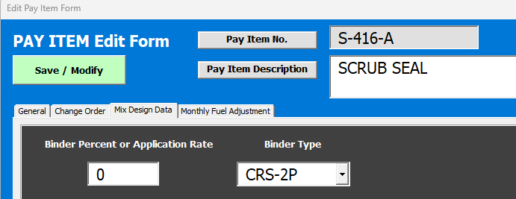

Fuel Code A3 – Asphalt for Prime
$$A3= Asphalt for Prime$$
$$A3 = (Quantity this Period (GAL)) ×\frac{1.0 gal}{unit}×\left(Current Month-Base Month\right)$$
$${A3}_{Total}= A3$$
Note: For “A3”, the program will change the calculation if the pay item units are square yard (SY). This is case sensitive.
The application rate must be entered for the calculation to work correctly. “x” equals the user input in gallons per square yard. The application rate is used the same way as an asphalt mix design and added on the Pay Item Edit Form.
$$A3 = \left(Quantity this Period (SY)\right)× \frac{x gal}{SY}×\left(Current Month-Base Month\right)$$

Fuel Code A4 – Asphalt for Curing Seal
$$A4= Asphalt for Curing Seal$$
$$A4 = (Quantity this Period) ×\frac{0.25 gal}{unit}×\left(Current Month-Base Month\right)$$
$${A4}_{Total}= A4$$

Fuel Code A5 – Asphalt for Bituminous Treated Roving
$$A5= Bituminous Treated Roving$$
$$A5= (Quantity this Period) ×\frac{0.50 gal}{unit}×\left(Current Month-Base Month\right)$$
$${A5}_{Total}= A5$$

Fuel Code A6 – Asphalt for Asphalt Drainage Course
$$A6= Asphalt for Asphalt Drainage Course$$
$$A6= \left(AC Content \% from mix design\right)×(Quantity this Period) ×2.375×\left(Current Month Binder-Base Month Binder\right)$$
$${A6}_{Total}= A6$$

Special Pay Item Fuel Adjustments
Currently only asphalt pay items have a special fuel adjustment based on the asphalt content percentage and binder type. Chemical treated soils are currently to be determined and the calculation does not work in the program at this time.
Instead of using the fuel code “B”, the user will enter fuel code “B A1”. This is case sensitive in the program and the space is necessary. Typically, PG-67-22 is the binder used in asphalt. The percent asphalt content and binder type must be specified for each pay item.
$$B A1= BHot Mix Asphalt (HMA)$$
$${B A1}_{AC_{Content}\%}= \left(AC Content \% from mix design\right) ×2.375 ×(Quantity this Period)××\left(Current Month Binder-Base Month Binder\right)$$
$$B_{Total}= B_{gasoline}+ B_{diesel}+{B A1}_{AC_{Content}\%}$$
See the fuel adjustments for the gasoline and diesel in the previous fuel adjustment section.

Damages & Forfeitures
The user manually enters the pre-calculated damages and forfeitures in the highlighted yellow field on the CAD-001 monthly summary invoice.

Advancements
The user may use the following method to calculate a quantity that can be used to represent and advanced payment of materials cost on a pay item. Advancements are allowed based on Section S-109.06.2--Advancement on Materials of MISSISSIPPI STANDARD SPECIFICATIONS FOR STATE AID ROAD AND BRIDGE CONSTRUCTION. The following example presents the calculation method. The detailed cost values shall be calculated outside of the program and approved by an OSARC representative. Note: There is an alternative way to represent the advancement. The user can “zero” out the initial quantities for that pay item. The user could create a prorated unit cost for advanced material cost and installation cost by create two (2) of the same pay item and splitting the total unit cost. The previous DOS program performed the advancement calculations in a manner to this alternative method described here.
- The 2 following pay items need to have a quantity entered in order to pay the Contractor and advanced payment for the materials cost.
- 901-S-804-C, 31' PRESTRESSED CONCRETE BEAM, TYPE I+2 materials cost for production was calculated to be equal to $33,671.12.
- 901-S-804-C, 40' PRESTRESSED CONCRETE BEAM, TYPE I+2 materials cost for production was calculated to be equal to $40,274.53.
- The quantity is back calculated based on the total contract amount for each pay item. The below table is an exert from the CAD-002 contract data.
Current Fuel Adjustment | Item Number | Fuel Code | Item | Quantities |  |  | Unit | Unit Price | Current Accumulative Amount | Contract Estimate Amount
 |  |  |  | Contract Amount | Current Period | Allowed to date
$- | 901-S-804-C | S | 31' PRESTRESSED CONCRETE BEAM, TYPE I+2 | 307.500 |  | 0.000 | LF | 177.50 | $- | $54,581.25
$- | 901-S-804-C | S | 40' PRESTRESSED CONCRETE BEAM, TYPE I+2 | 397.500 |  | 0.000 | LF | 166.35 | $- | $66,124.13

$$Current Period Advanced Quantity= \frac{\$ Material Cost}{Contract Estimate Amount}×\left(Quantities Contract Amount\right)$$

$$901-S-804-C, {31}^{'}PRESTRESSED CONCRETE BEAM$$
$$Advanced Quantity= \frac{\$33,671.12}{\$54,581.25}×\left(307.50 LF\right)=189.6964507 ≈189.696$$
$$901-S-804-C, {40}^{'}PRESTRESSED CONCRETE BEAM$$
$$Advanced Quantity= \frac{\$40,274.53}{\$66,124.13}×\left(397.50 LF\right)=242.1071653≈242.107$$

$$Advanced Quantity= \$177.50×\left(189.696 LF\right)=\$33,671.04$$
$$Advanced Quantity= \$166.35×\left(242.107LF\right)=\$40,274.50$$
These advanced payment will be calculated and represented under the “Current Accumulative Amount”. Retainage is automatically calculated on the CAD-001. A note identifying that that an advancement is paid shall be noted on the CAD-001.
Current Fuel Adjustment | Item Number | Fuel Code | Item | Quantities |  |  | Unit | Unit Price | Current Accumulative Amount | Contract Estimate Amount
 |  |  |  | Contract Amount | Current Period | Allowed to date
$- | 901-S-804-C | S | 31' PRESTRESSED CONCRETE BEAM, TYPE I+2 | 307.500 | 189.696 | 0.000 | LF | 177.50 | $33,671.04 | $54,581.25
$- | 901-S-804-C | S | 40' PRESTRESSED CONCRETE BEAM, TYPE I+2 | 397.500 | 241.498 | 0.000 | LF | 166.35 | $40,274.50 | $66,124.13

Training Videos
The user may use the following videos to assist with training. The user should also be aware that minor changes and updates may occur and be displayed differently in the video. Major updates will be followed by a new training video. Users will need to be added to the Microsoft Team for the Estimate Invoice Program to access these videos.
General Topic | Training Video(s) | Duration (min:sec)
Getting Started | Getting Started - Training Video #1  Getting Started - Training Video #1 (Version 2.0) | 07:43  05:30
Project Data | Project Data for County Engineer - Training Video #1  Project Data for County Engineer - Training Video #1 (Version 2.0) | 06:58  04:31
Engineer’s Estimate, 900, 902, and Pay Items | Engineer's Estimate, 900, 902, & Pay Items - Training Video #1  Engineer's Estimate, 900, 902, & Pay Items - Training Video #1 (Version 2.0) | 10:56  08:03
Pay Items | New Pay Items and Pay Item Ordering  New Pay Items and Pay Item Ordering (Version 2.0)  Pay Item is Not Available in DropDown List  Pay Item is Not Available in DropDown List (Version 2.0)  Editing Pay Items  Editing Pay Items (Version 2.0) | 02:56  03:24  03:29  07:06  02:39  04:20
Form 900 | Form 900 Exporting to Word or PDF | 05:13
Form 902 / Modifying Templates | Form 902 Debug Error Modified Template | 05:33
Estimate | OSARC Preliminary Estimate  OSARC Preliminary Estimate (Version 2.0) | 03:05  03:36
Bid Tab | Bid Tab & Web Bid List  Bid Tab & Web Bid List (Version 2.0)  Bid Tab Functions for District Engineers (DE)  Bid Tab Functions for District Engineers (DE) (Version 2.0) | 03:42  03:52  03:02  07:39
Letting Results | Letting Results and Contractor’s Estimate  Letting Results and Contractor’s Estimate (Version 2.0) | 05:00  03:29
Materials Testing | Materials Testing Report | 01:56
Average Unit Cost | Average Unit Cost | 05:13
CAD-001 and CAD-002 | CAD-001 and CAD-002 Template Preparation  CAD-001 and CAD-002 Template Preparation (Version 2.0) | 06:55
CAD-002 | Excel File Size Reduction (Version 1.0) | 04:39
CAD-001 and CAD-002 | Monthly Invoices CAD-001 and CAD-002  Monthly Invoices CAD-001 and CAD-002 (Version 2.0)  - Enter / Update Current Monthly Fuel Adjustment  - Calculate amounts  - Save and print fuel adjustment data | 12:40
CAD-001 and CAD-002 | Monthly Invoice Editing Pay Items for different Fuel Adjustments (Version 2.0) | 04:27
CAD-001 and CAD-002 | Corrections (Version 2.0) | 06:46
CAD-002 | Asphalt Mix Design Data  Asphalt Mix Design Data (Version 2.0)  - This data must be entered or the fuel adjustment will not calculate correctly. Since this information is typically unknown prior to the construction phase of the project, the user must edit the pay item and update the CAD-002 template | 04:26  02:43
Engineers Payment | Engineer's Progress Estimate Invoice  Engineer's Progress Estimate Invoice (Version 2.0) | 05:57  07:10
CAD-002 | Change Order on Existing Pay Items  Change Order on Existing Pay Items (Version 2.0) | 08:59  06:20
CAD-002 | Change Order to Change the Working Days  Change Order to Change the Working Days (Version 2.0) | 02:34  01:57
CAD-002 | Change Order to add a Supplemental New Pay Item  Change Order to add a Supplemental New Pay Item (Version 2.0) | 07:28  06:42
CAD-001 and CAD-002 | Final Invoices CAD-001 and CAD-002  Final Invoices CAD-001 and CAD-002 (Version 2.0) | 05:48  02:15
CAD-002 | Reduce Excel Program Version 1.0 File Size | 05:12
CAD-002 | New Supplemental Pay Item during Construction and DON’T Do This | 07:25
General | Described general processes relevant to the program.  - Engineer's Estimate Workflow  - OSARC Estimate to Bid Tab Workflow  - Excel Program County Folder Portal | 10:23  09:00  09:02

Cost Savings Project Summary
Beginning in approximately January 2019, the project to replace the “OSARC DOS Estimate Program” and “SAIDS” project management tracking database was started. SAIDS is also DOS based. This project was a a business case IT project that eventually became Project Number #43417-4329. Funding of this project would be taken directly from the OSARC administrative funds. Hence, the overall project budget would decrease by that amount statewide. After completing the complicated task of state procurement through ITS and many hours invested by many OSARC employees, the project narrowed down the vendors to a single low bidder in May 2022. The total cost was $1,111,860 over a period of 5 years. At the end of 5 years, this procurement process would need to be repeated. There is not guarantee the current low bidder would be the low bidder in 5 years. Hence, OSARC may have to switch software in 5 years to another vendor, which seems problematic. In addition, the funded project did not include a replacement for the DOS Estimate Program and this would required additional development and likely cost tens of thousands of dollars.

Project Management System Replacement
In the summer of 2021, Roadway Review began development of a project management software to replace SAIDs. On June 1, 2022, Roadway Review has discontinued use of SAIDs due to the success of currently available software. Microsoft PowerApps, PowerAutomate, Forms, Sharepoint, and Teams have been used to create a more robust and user friendly project management experience. The following include improvements and highlights of implementation:
- Cost equals $0.00 additional amount from administrative budget
- Automated emails notifying status updates
- Project data access via phone or tablet
- Externally accessible data queries
Moreover, Bridge Review has also been added to this project management system as of June 1, 2022. The same benefits apply. Roadway Review is working with Contracts to create their project management system as of June 1, 2022. Roadway Review will continue to implement and train other areas at OSARC to replace SAIDs will these successful technologies.

Estimate Program Replacement
Starting in February 2022, Roadway Review begin creating an Excel program that would replace the OSARC DOS Estimate program. By June 1, 2022, the Excel Estimate / Invoice Program has successfully replaced approximately 95% of the functions of the old program. Future updates will expand functionality beyond the old estimate program. An implementation strategy is currently being created. OSARC Estimate Invoice Program Version 1.3 initial release was November 2022 and incorporates many updates and improvements. Program Version 1.4 is tentatively planned to be released by October 2023 and will incorporate the ability to export unit cost data to SQL to determine the average unit cost of pay items as well as many other improvements.
April 1, 2025 marks the release of Version 2.0 of the program. The following presents some of the program improvements but is not an exhaustive list:
- Download file size has been reduced from 20.6 megabytes to 1.6 megabytes. The previous version generally could not be emailed.
- An individual pay item could have specific fuel adjustment data. For example, pay items from January 2025 could be added to a March 2025 invoice and the fuel adjustment would calculate correctly.
- The CAD-001 and CAD-002 is no longer a 2 step process. The CAD-001 and CAD-002 are combined into 1 sheet for processing.
- An improved fuel adjustment summary is added to the bottom of the CAD invoice. The user can view the fuel adjustment prior to printing.
- The monthly pay items used are summarized at the bottom of the CAD invoice.
- The fuel month and year are included on the CAD invoice.
- The user can update or clear the logo for all the documents and upload their own image automatically. Also the heading of documents can be changed. This was added so users can use the program on non-OSARC projects if desired.
- The BidTab letting results entering process by the OSARC DE was streamline.
- Many of the “template” documents were hidden from users in order to prevent user errors.
- The “Dashboard” and other data forms were merged into 1 form for improved user experience.
- OSARC 2004, OSARC 2024, and MDOT 2017 specification pay item are available in the program.
- The user can now modify the “sort” order of pay items at their discretion.
- The S-200-A Mobilization and S-618-A Maintenance of traffic were required by the CAD invoice in the old program. However, some projects did not use these pay items and these were automatically calculated. The requirement has been removed.
- A “correction” mechanism has been added to modify invoices submitted for common problems encountered. The “correction” modifies the CAD-001 amount but does not change the contract total amount.
- Essentially and ultimately number of User Defined Types and Supplemental Pay Items / Corrections can be added to the program.
- The program processes faster than the previous version.
- The program automatically updates itself based on the winning bid unit cost and this will improve data entry error.
- Direct entry into Excel sheets has been eliminated and replaced with user forms to improve the workflow.

Process FlowChart
This flowchart is a general overview of the workflow that is planned to be used for the Excel Program. This flowchart contain many but not all detailed steps. The mail image,  , indicates the user for that particular step will need to generate the automated email in the system to proceed to the next step in the process. This is the easiest way to notify OSARC of the desired next step.
Letting Results
Posted on the OSARC Website
by IT
 Contracts generates the email by selecting “CAD”
CE downloads program from the email link to begin invoicing
Contracts prepares the CAD-001 and CAD-002 template included base fuel adjustment prices
Contracts updates to unit price in the program and generates the Contractor’s Estimate
Contracts generates the Letting Results.
PDF created and emailed to IT
 Contracts generates the email by selecting “Bid Tab”
 Roadway generates the email by selecting “OSARC Estimate”
 DE generates the email by selecting “Bid Letting”
 Select “Engineers Estimate”
DE enters bid letting results
on the Bid Tab
Bid Tab Prepared by
Contracts. WebBidList sent to IT
Bid Date Set by DE and
Roadway Review
OSARC Estimate
Edited by Addendum
OSARC Estimate
Created Roadway Review
Alternatively CE emails program to Roadway@osarc.ms.gov

CE copies Excel Program File
Drag/Drop to
Sharepoint County Folder Link
CE creates
Engineer’s Estimate, 900, 902

Training Class Course Outline
The following section presents the current training class outline. The training class duration is about 3 hours and the user should have access to a computer to improve the training quality.
- Estimate / Invoice Program Specifications
- Create / Modify Project Data
- Create / Modify Pay Items
- Engineer’s Estimate
- Form 900, Form 902, and Green Cover Sheet
- OSARC Preliminary Estimate
- Bid Letting Process
- Contractor’s Estimate
- CAD-002 template
- Base fuel adjustment
- CAD-001 template
- CAD-001 and CAD-002 monthly invoicing
- Change Orders
- Future Updates Procedure
  - New improved features
  - Code or Error updates
  - Notification process
- Future Training
- Project Management System Overview
  - Online Forms
  - Status Reports
  - Automated Emails

